FAYA JAVA APP - PHASE 1 UPDATES CODE CHALLENGE

Revision History
Author | Revision Number | Date
TCSDEVELOPER | 1.0 | 2017-01-02

1. Organization of Submission 3
2. Prerequisites 3
3. Configuration 3
faya-api module 3
fundyield-api module 4
4. Database Setup 4
5. Application Setup 5
6. Unit Tests 5
7. Verification 5
faya-api 6
fundyield-api 8
8. Resource Contact List 9

Organization of Submission

docs
Contains deployment guides and Postman collection files.

faya-commons
The common code module.

faya-api
The FAYA REST API module.

fundyield-api
The Fund Yield public REST API module.

sql
Contains sql scripts that used to create db schema (db user, table, procedure…).

test_data
Contains sql scripts that populate the db with test data.

README.md
The project documentation in Markdown format.

Prerequisites

Java 8 http://www.oracle.com/technetwork/java/javase/downloads/jdk8-downloads-2133151.html
Tomcat 8 https://tomcat.apache.org/download-80.cgi
Maven https://maven.apache.org/download.cgi
Oracle 11g http://www.oracle.com/technetwork/database/database-technologies/express-edition/downloads/index.html

Configuration

faya-api module

These are the most important variables that can be configured for faya-api module:

Name | Location | Description | Example value
operationScale | faya-api  src/main/resources/constants.properties | The operation scale used by calculator engines | 7
roundingMode | faya-api  src/main/resources/constants.properties | The rounding mode  used by calculator engines | 4
oracle.url | faya-api  src/main/resources/db.properties | The Oracle url | jdbc:oracle:thin:@localhost:49161:xe
oracle.username | faya-api  src/main/resources/db.properties | The Oracle username | secyield
oracle.password | faya-api  src/main/resources/db.properties | The Oracle password | passwd

For tests, make sure you provide the correct db credentials in faya-api/src/test/resources/test-db.properties:

oracle.driverClassName=oracle.jdbc.driver.OracleDriver
oracle.url=jdbc:oracle:thin:@localhost:49161:xe
oracle.username=test_secyield
oracle.password=password

fundyield-api module

These are the most important variables that can be configured for fundyield-api module:

Name | Location | Description | Example value
secyieldcontroller.maxNumberOfSecurityData | fundyield-api  src/main/resources/constants.properties | The maximum number of security data to be returned by the API | 100
getConfigApiPath | fundyield-api  src/main/resources/application.properties | The path to get SEC configuration from faya-api | http://localhost:8081/faya-api/securitySECDataConfiguration
getSecuritySECDataApiPath | fundyield-api  src/main/resources/application.properties | The path to get SEC data from faya-api | http://localhost:8081/faya-api/fayaFundAccountingSECYieldData
saveCalculatedSecuritySECDataApiPath | fundyield-api  src/main/resources/application.properties | The path to save calculated SEC data from faya-api | http://localhost:8081/faya-api/calculatedFundAccountingSECYieldData
getCalculatedSecuritySECDataApiPath | fundyield-api  src/main/resources/application.properties | The path to get calculated SEC data from faya-api | http://localhost:8081/faya-api/calculatedFundAccountingSECYieldData

Database Setup

Follow these steps to get the APIs running:

Use Oracle SQL Developer to connect to Oracle.

Run sql/create_user.sql. This will create the two users secyield and test_secyield.

Connect as secyield user, run sql/schema.sql and sql/procedures.sql. This will create the table structure and store procedures for user secyield.

Connect as test_secyield user, run sql/schema.sql and sql/procedures.sql. This will create the table structure and store procedures for user test_secyield.

In case you want to load some test data, run test_data/clear.sql and test_data/test_data.sql

Application Setup

In faya-commons folder, run the following command:

$ mvn clean install

In faya-api folder, run the following commands:

$ mvn install:install-file -Dfile=lib/ojdbc6.jar -DgroupId=com.oracle -DartifactId=ojdbc6 -Dversion=11.2.0 -Dpackaging=jar
$ mvn clean install
$ mvn spring-boot:run

In fundyield-api folder, run the following commands:

$ mvn clean install
$ mvn spring-boot:run

Unit tests are run by default, use -DskipTests parameter to skip unit tests:

$ mvn clean install -DskipTests

Unit Tests

In faya-commons, faya-api and fundyield-api folder, run the following command:

$ mvn test

Verification

All input dates for the 2 REST APIs must follow this format: yyyy-MM-dd

The test_data/test_data.sql will insert sample data for date: 2014-12-01

Open docs/faya-api.postman_collection.json and docs/fundyield-api.postman_collection.json in Postman application

faya-api

GET http://localhost:8081/faya-api/securitySECDataConfiguration

Gets SEC security config for the calculations in engines:

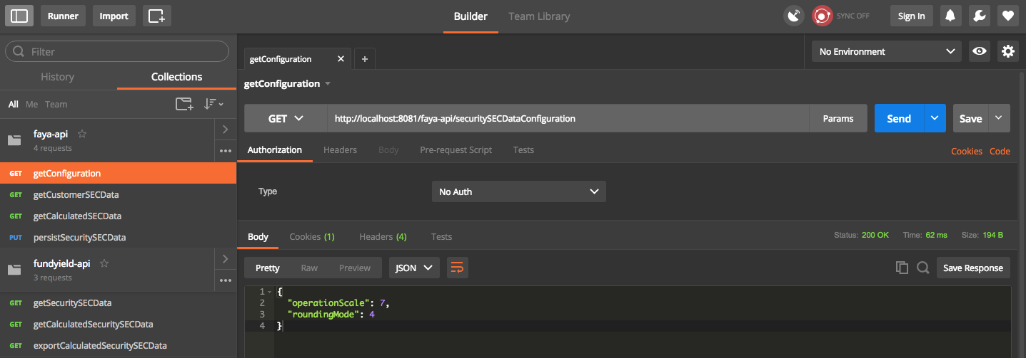

GET http://localhost:8081/faya-api/fayaFundAccountingSECYieldData?businessDate=2014-12-01

Gets the customer SEC security data:

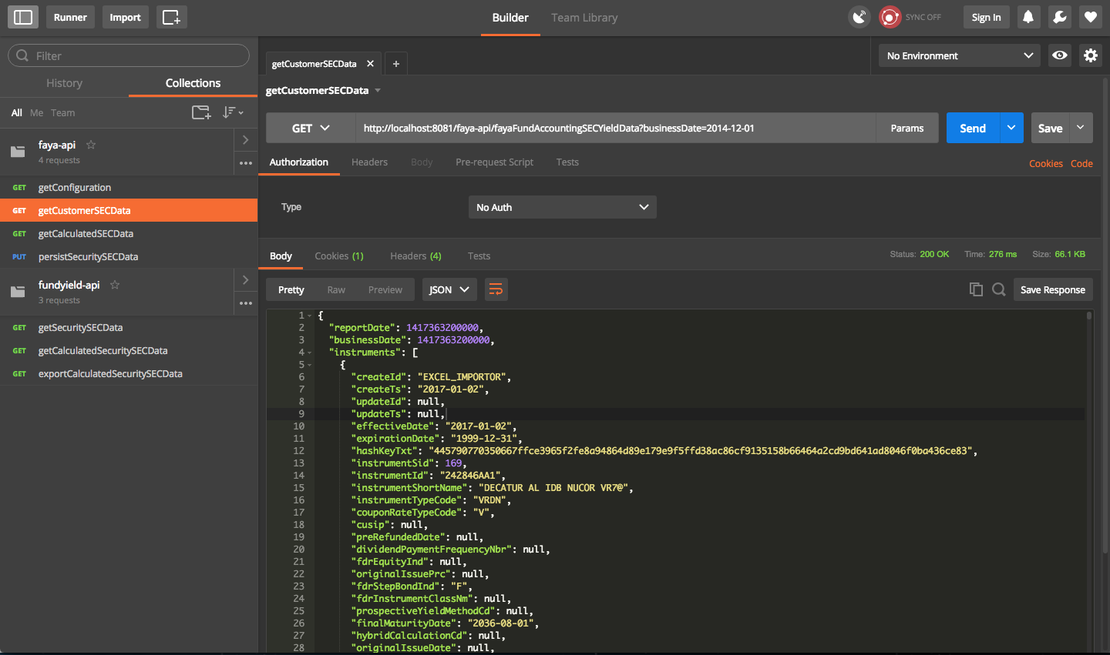

GET http://localhost:8081/faya-api/calculatedFundAccountingSECYieldData?businessDate=2014-12-01

Gets the calculated SEC security data:

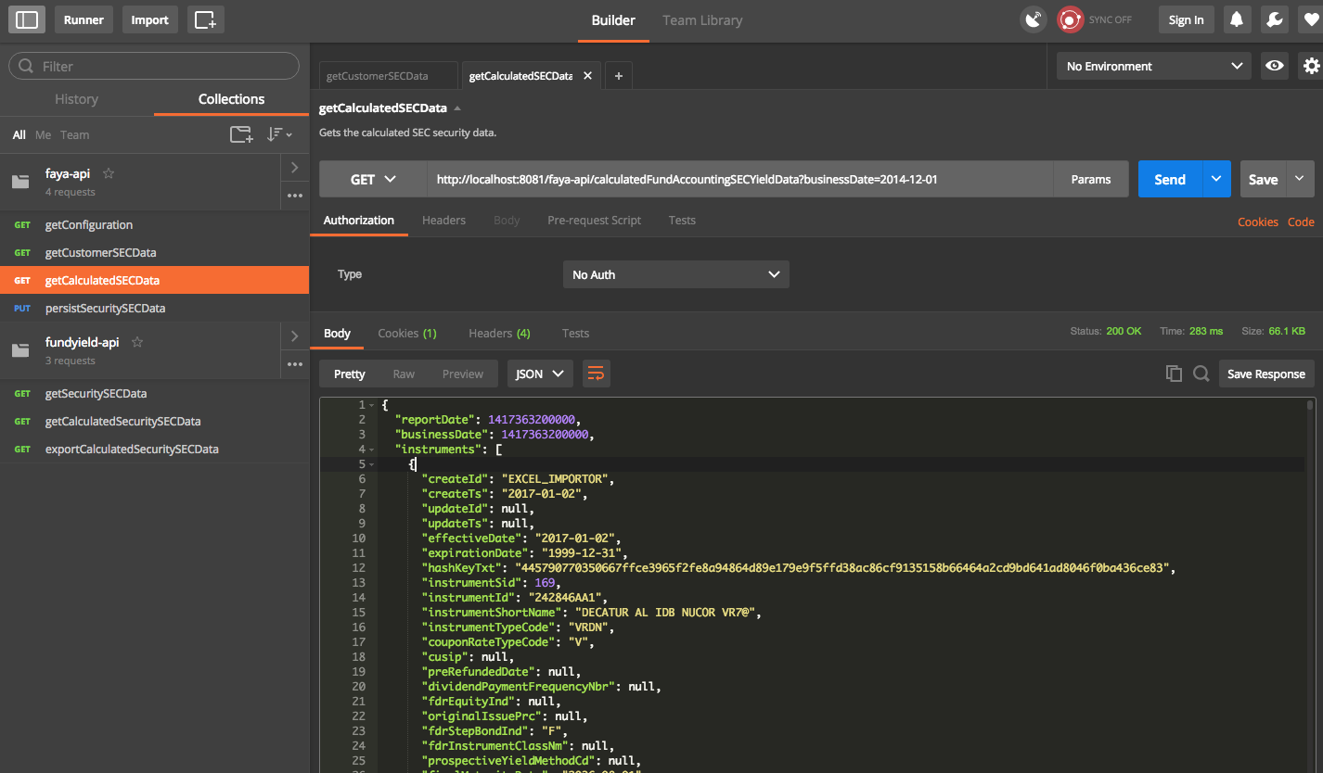

PUT http://localhost:8081/faya-api/calculatedFundAccountingSECYieldData

Persists the calculated SEC security data:

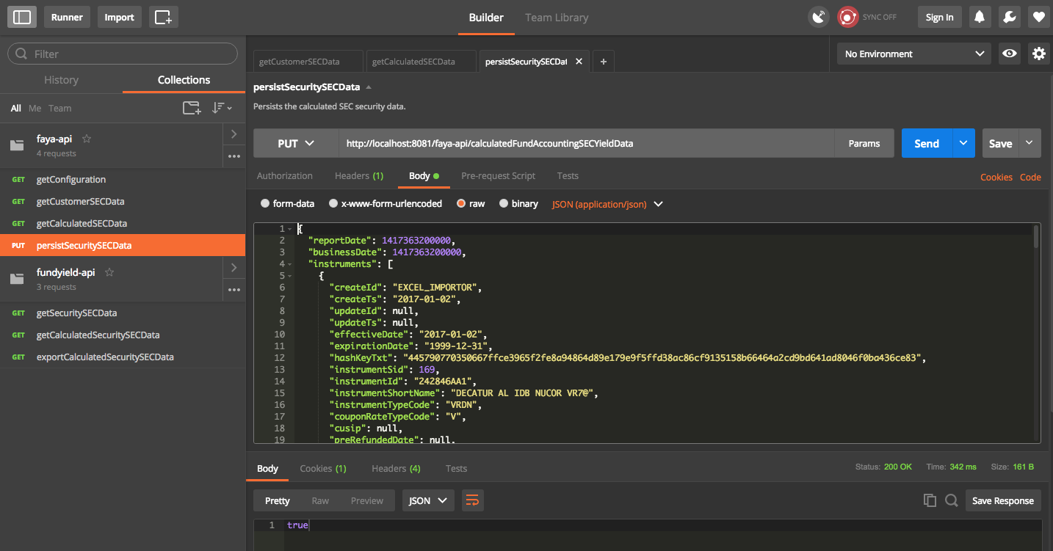

fundyield-api

GET http://localhost:7090/fundyield-api/fundAccountingSECYieldData?businessDate=2014-12-01

Gets SEC Security data with the calculated data for the business date. The securities are also persisted using customer REST API:

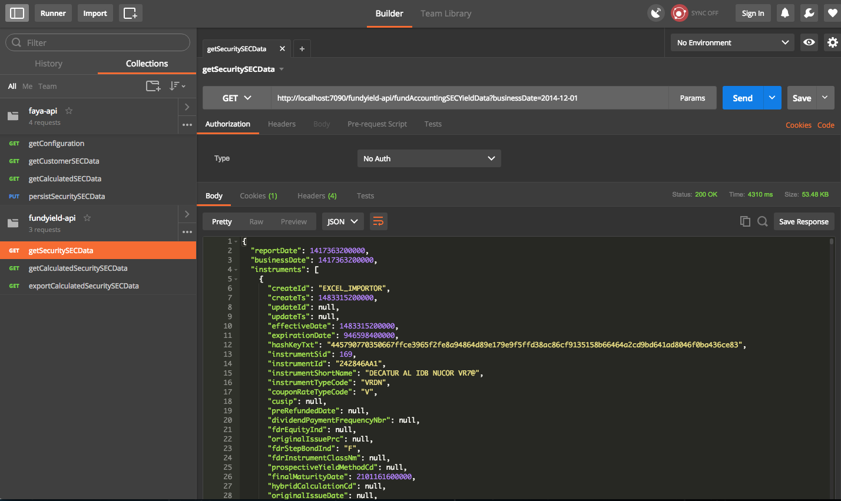

GET http://localhost:7090/fundyield-api/calculatedFundAccountingSECYieldData?businessDate=2014-12-01

Gets already calculated SEC Security data for the given date:
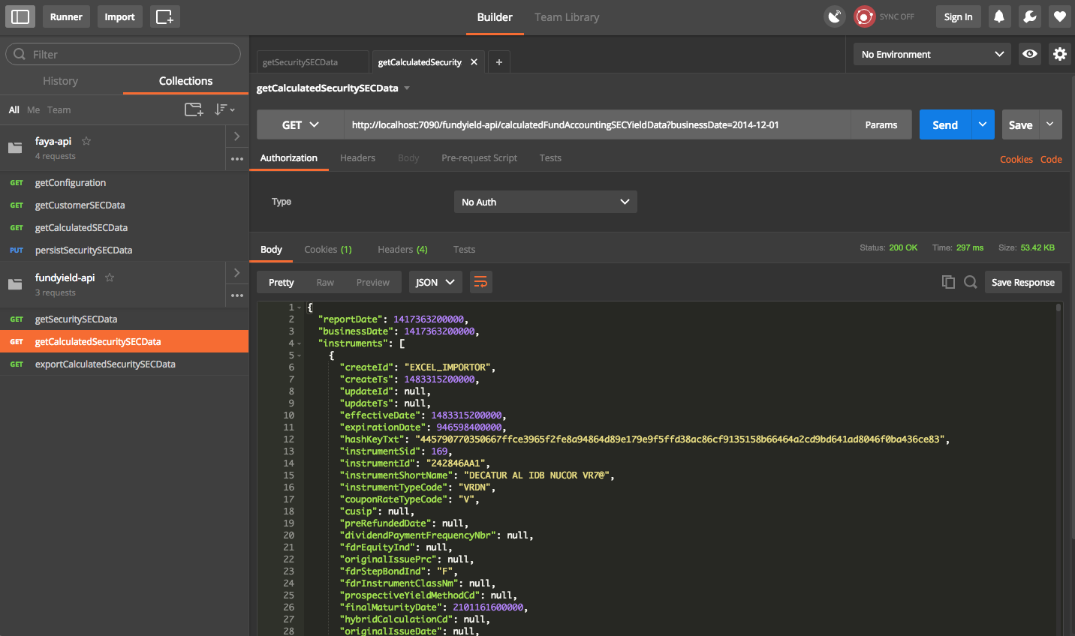

GET http://localhost:7090/fundyield-api/exportCalculatedFundAccountingSECYieldData?businessDate=2014-12-01

Exports calculated SEC Security data for the given date:

For downloading, click the arrow near the Send button and then click “Send and Download”.

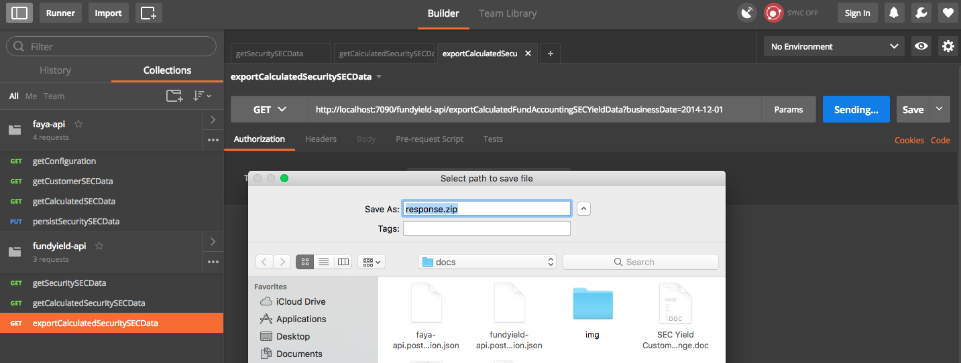

In order to get the correct file name of the export, please test this url in a browser.

Sample Export file:

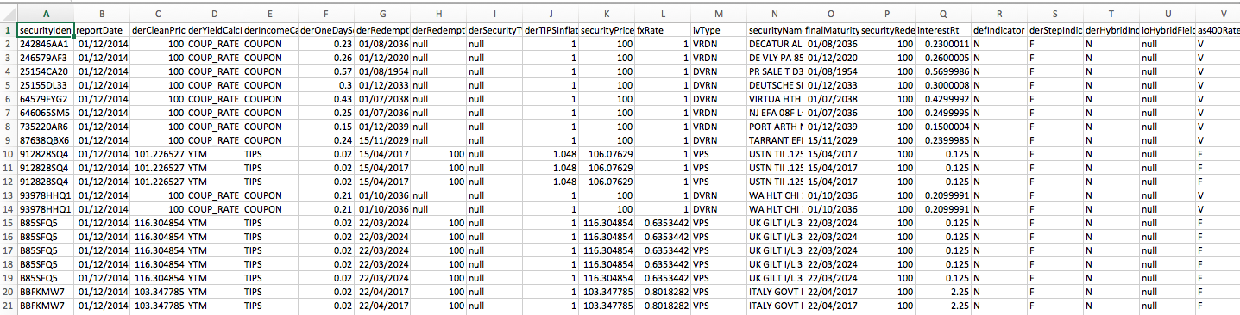

Resource Contact List

Name | Resource Email
TCSASSEMBLER

